NICHOLAS MCGEGAN, CONDUCTOR
913 words
~
Music Director Laureate, Philharmonia Baroque Orchestra and Chorale
Principal Guest Conductor, Capella Savaria

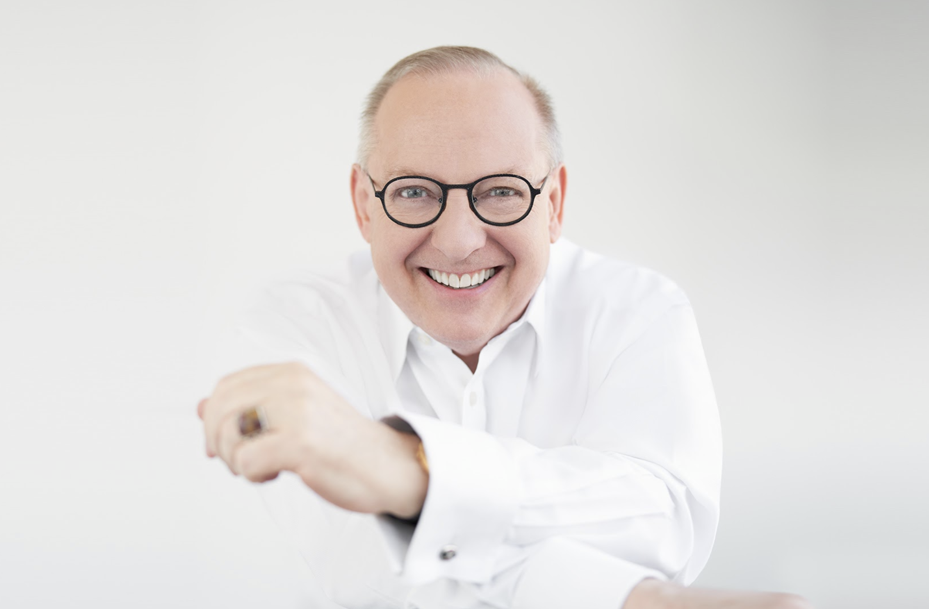
In his sixth decade on the podium, Nic McGegan — long hailed as “one of the finest baroque conductors of his generation” (The Independent) and “an expert in 18th-century style” (The New Yorker) — is recognized for his probing and revelatory explorations of music of all periods. Following a 34-year tenure as Music Director of Philharmonia Baroque Orchestra and Chorale, he is now Music Director Laureate. He is also Principal Guest Conductor of Hungary’s Capella Savaria. At home in opera houses, McGegan shone new light on close to 20 Handel operas as the Artistic Director and conductor at Germany’s International Handel Festival Göttingen for 20 years (1991–2001), and the Mozart canon as Principal Guest Conductor at Scottish Opera in the 1990s. He was also Principal Conductor of Sweden’s Drottningholm Court Theatre from 1993 to 1996.

Best known as a Baroque and Classical specialist, McGegan’s approach — intelligent, infused with joy, and never dogmatic, along with an ability to engage players and audiences alike — has made him a pioneer in broadening the reach of historically informed practice beyond the world of period ensembles to conventional symphonic forces. His guest-conducting appearances with major orchestras — including the New York, Los Angeles, and Hong Kong Philharmonics; the Chicago, Dallas, Milwaukee, Toronto, Sydney, and New Zealand Symphonies; the Philadelphia Orchestra; the Royal Northern Sinfonia and Scottish Chamber Orchestras; and the orchestras of London's Royal Opera House and Amsterdam's Royal Concertgebouw — often feature Baroque repertoire alongside Classical, Romantic, 20th-century, and even brand-new works. He has conducted Mendelssohn, Sibelius, Britten, Bach, and Handel with the Utah Symphony; Poulenc and Mozart with the City of Birmingham Symphony Orchestra; and the premiere of Stephen Hough’s Missa Mirabilis with the Indianapolis Symphony Orchestra, paired with Haydn, Brahms, and Mendelssohn. He collaborates frequently with the Mark Morris Dance Group, including the premiere productions of Rameau’s Platée and Handel’s Acis and Galatea, and has led performances at the BBC Proms and the Edinburgh International Festival.

Highlights of his 23/24 orchestral bookings include performances at the Aspen Music Festival and School; leading the Cleveland Orchestra in a program of Mozart and Mendelssohn at the 2023 Blossom Music Festival; a return to the Hollywood Bowl in a “Mozart Under the Stars” concert with the Los Angeles Philharmonic; two programs with the Bay Area’s Cantata Collective; engagements with the Detroit Symphony, Sarasota Orchestra, and Rhode Island Philharmonic; and performances of Handel’s Messiah with the Philadelphia Orchestra; Calgary Philharmonic; and the Grand Rapids, Edmonton, and New Jersey Symphonies.

On the operatic front this season, McGegan will conduct performances of two Handel operas: L’Allegro, il Penseroso ed il Moderato at the Curtis Institute of Music; and Giulio Cesare at the Blackwater Valley Opera Festival in Lismore, Ireland as well as concert performances of Handel’s Deborah with the NDR Radiophilharmonie in Herrenhausen and Göttingen, Germany.

McGegan’s prolific discography includes more than 100 releases spanning five decades. Having recorded over 50 albums of Handel — two of which received the U.K.’s prestigious Gramophone Award — McGegan has explored the depths of the composer’s output with a dozen oratorios and close to 20 of his operas. Since the 1980s, more than 20 of his recordings have been with Hungary’s Capella Savaria on the Hungaroton label, including groundbreaking recordings of repertoire by Handel, Monteverdi, Scarlatti, Telemann, and Vivaldi. McGegan also released two albums with the Swedish Chamber Orchestra under the BIS label: Josef Mysliveček’s complete music for keyboard with soloist Clare Hammond; and an album of early horn concertos with soloist Alec Frank-Gemmill. His extensive discography with Philharmonia Baroque includes two GRAMMY nominations, for Handel’s Susana and Haydn’s Symphonies 104, 88, and 101. Recent releases include an album of Mozart violin concertos with violinist Gil Shaham and the SWR Symphonie Orchester, and a recording of Mozart’s double concertos with violinist Zsolt Kalló and Capella Savaria.

With Cantata Collective, McGegan has released the first volume in an ongoing initiative to record all of Bach's Cantatas, which received critical praise from Early Music America and American Record Guide. McGegan and Cantata Collective have also announced a new partnership with AVIE Records to record Bach’s six choral masterpieces — the St John and St Matthew Passions, Mass in B Minor, Christmas and Ascension Oratorios, and the Magnificat — over the next five years. The first album in this ambitious project, the St John Passion, was released in May 2023.

Mr. McGegan is committed to the next generation of musicians, frequently conducting and coaching students in residencies and engagements at Yale University, the Juilliard School, Harvard University, the Colburn School, Aspen Music Festival and School, Sarasota Music Festival, and the Music Academy of the West. He has been awarded the honorary degree of Doctor of Music by the San Francisco Conservatory of Music; an honorary professorship at Georg-August University, Göttingen; and in 2016 was the Christoph Wolff Distinguished Visiting Scholar at Harvard. McGegan’s fun and informative lectures have delighted audiences at Juilliard, Yale Center for British Arts, American Handel Society, and San Francisco Conservatory.

English-born, McGegan was educated at Cambridge and Oxford. He was made an Officer of the Most Excellent Order of the British Empire (OBE) “for services to music overseas.” Other awards include the Halle Handel Prize; the Order of Merit of the State of Lower Saxony (Germany); the Medal of Honour of the City of Göttingen; and a declaration of Nicholas McGegan Day by the Mayor of San Francisco, in recognition of his work with Philharmonia Baroque.

For more information, visit nicholasmcgegan.com or visit his Facebook page at facebook.com/nicholasmcgegan.

Last updated: May 2023

