NICHOLAS MCGEGAN, CONDUCTOR
208 words
~
Music Director Laureate, Philharmonia Baroque Orchestra and Chorale
Principal Guest Conductor, Capella Savaria

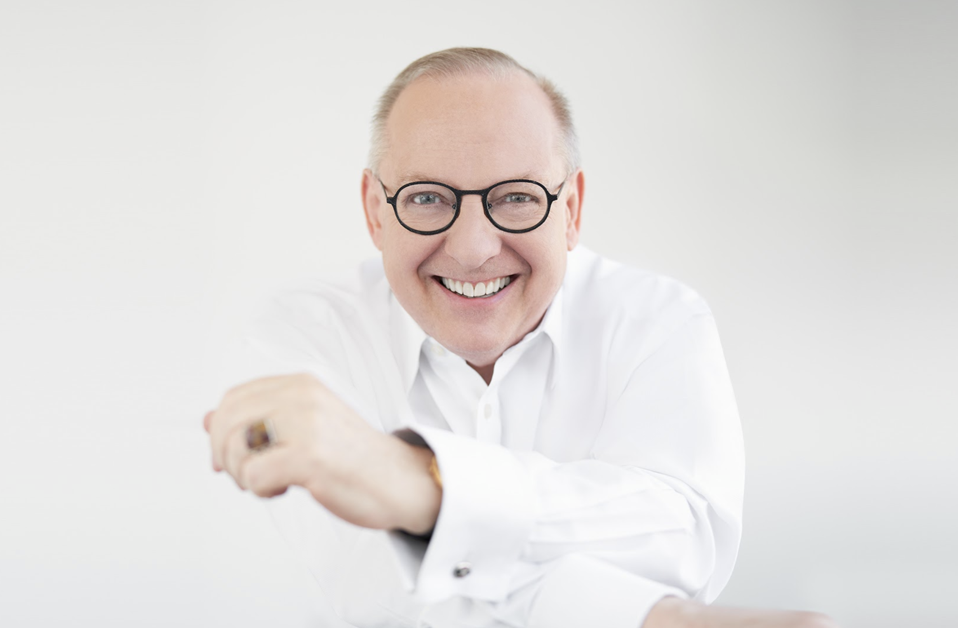
An “expert in 18th-century style” (The New Yorker), Nicholas McGegan is in his sixth decade on the podium. Following a 34-year tenure as Music Director of Philharmonia Baroque Orchestra and Chorale, he is now Music Director Laureate. He is also Principal Guest Conductor of Hungary’s Capella Savaria.
McGegan’s approach — intelligent, infused with joy, and never dogmatic — has led to engagements with many of the world’s major orchestras, including those of Cleveland, Chicago, Los Angeles, New York, Philadelphia, San Francisco, Hong Kong, Sydney, London's Royal Opera House, and the Royal Concertgebouw; regular collaborations with choreographer Mark Morris; and appearances at the BBC Proms and the Edinburgh International Festival.

His extensive discography includes more than 100 releases spanning five decades, including more than 40 with Philharmonia Baroque Orchestra and Chorale, and more than 20 with Capella Savaria. McGegan's recordings have garnered two Gramophone Awards and two GRAMMY nominations.

He was made an Officer of the Most Excellent Order of the British Empire (OBE) “for services to music overseas.” McGegan is committed to the next generation of musicians, frequently conducting and coaching students in regular engagements at Yale, Juilliard, Harvard, the Colburn School, Aspen Music Festival, and more.

For more information, visit nicholasmcgegan.com or visit his Facebook page at facebook.com/nicholasmcgegan.

Last updated: April 2023

